***CSCI 181 Web Design and Programming***

***Lab 1. Publishing simple web page.***

***Due: Friday, Aug 31st @ 5pm (Moodle dropbox)***

**Instructions**: For this first lab assignment, you are to create a very simple web page for your new family restaurant and publish it on the students.cs.umt.edu server.

**Learning Outcomes**:

* Basic structure of HTML pages
* Entering Titles and Body content
* Saving files in correct format
* FTP to Web server
* Basic Unix commands
* Creating folders and saving files within

**Sample final product:**

This is a sample final product only. You should change all headings and descriptions to reflect your own family restaurant. Just make sure all the special requirements are implemented as noted.

Should have some ***heading*** style 1

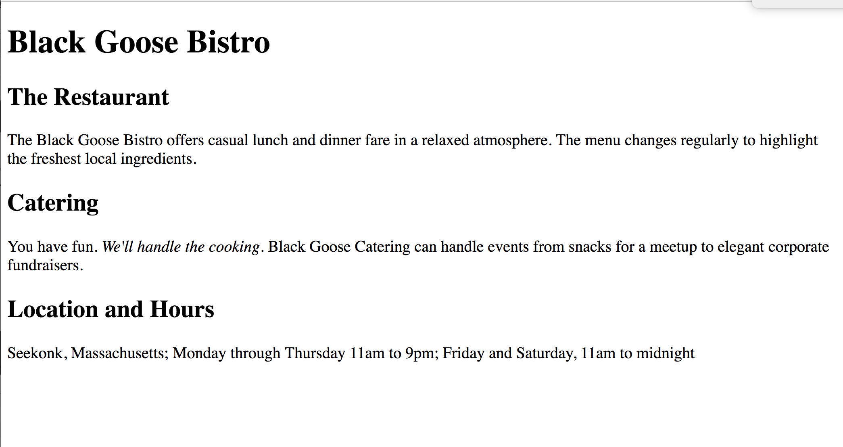

Should have some ***heading*** style 2

Should have at least 3 ***paragraphs***

Some text should be ***emphasized***

**Instructions and Requirements:**

1. Open up a new text file on your computer. Save it as plain text with a .html extension and give it the following name: CSCI181_Lab1_*yourlastname* (e.g., CSCI181_Lab1_Reimer).
2. Type in the standard HTML structure as shown below that you should use in all of your HTML files from here on out. Red tags are required. Black words are your specific input.

<!DOCTYPE html>

<html>

<head>

<meta charset = “utf-8”>

<title> put your title here </title>

</head>

<body>

page content

</body>

</html>

1. Create a web page like the sample shown above that adheres to all the requirements noted.
2. When you are done, FTP the page to the students.cs.umt.edu server. This file should reside in a folder called Lab1 within your public_html directory.
3. Submit your URL for your published restaurant web page.